# StreamSets with LDAP

Instalar o openldap-clients

* Yum -y install openldap-clients

Executar o comando a seguir para testar a conexão com o AD:

* Ldapsearch -x -b “dc=domain,dc=controller” -D [usuariodeadmdoAD@domain.controller](mailto:usuariodeadmdoAD@domain.controller) -LLL -H ldap://hostnamedomaincontroller:389 -W ‘(&(objectClass=person)(sAMAccountName=conta_do_usuario))’

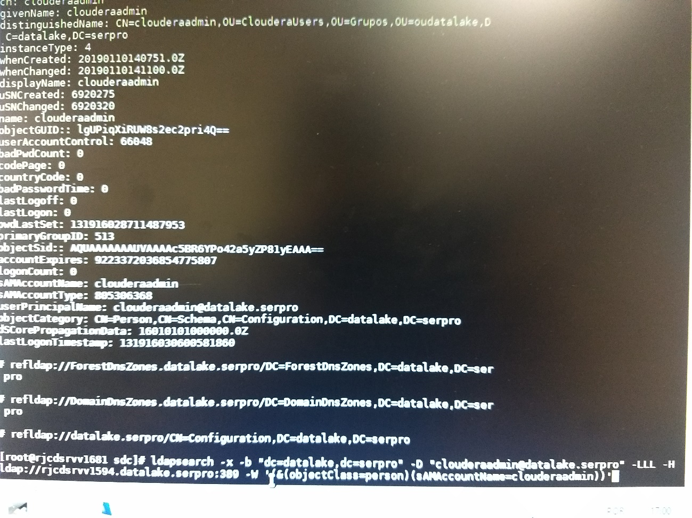

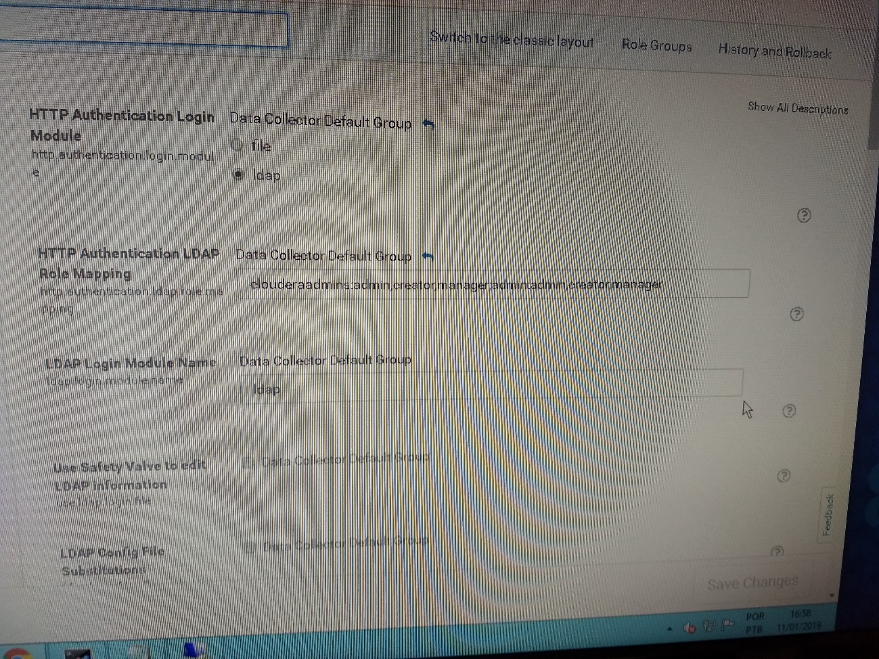

HTTP Authentication Login Module: ldap

HTTP Authentication LDAP Role Mapping: clouderaadmins:admin,creator,manager,guess;outro_grupo:guess

Force Binding Login for LDAP: Marcar

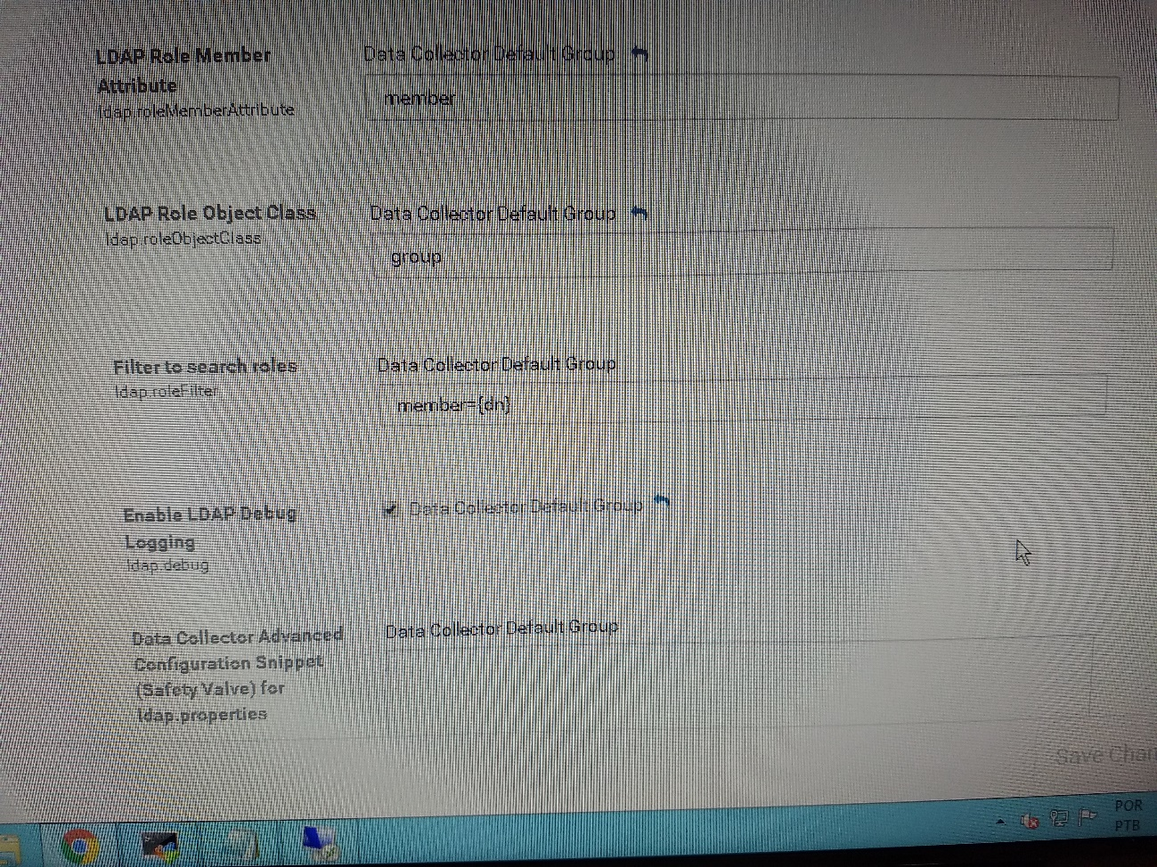

LDAP Role Member: member

LDAP Role Object Class: group

Filter to search roles: member={dn}

Enable LDAP debug Logging: Marcar caso precise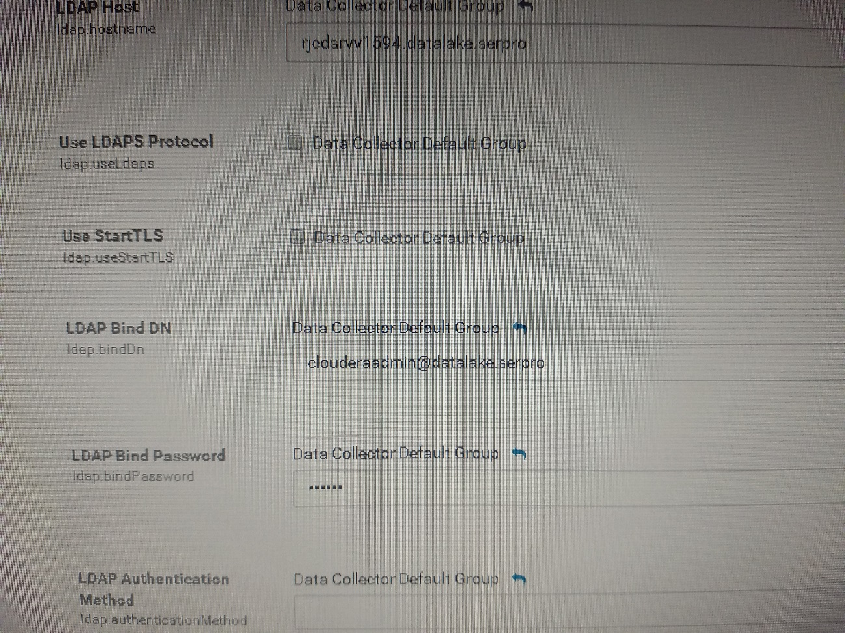

LDAP Host: FQDN do AD

LDAP Bind DN: usuário com privilégios de administrador do AD

LDAP Bind Password: senha do usuário

LDAP Authentication Method: deixar em branco

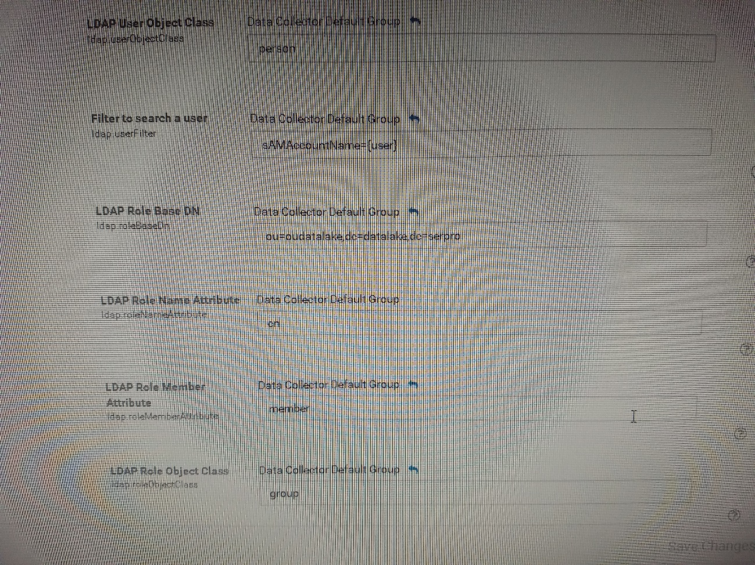

LDAP UserName Attribute: deixar em branco

LDAP User ID Attribute: sAMAccountName

LDAP User Password Attribute: userPassword

LDAP User Object Class: person

Filter to search a user: sAMAccountName={user}, user vem da interface do streamsets

LDAP Role Base DN: ou=users,dc=lab,dc=local

LDAP Role Name Attribute: cn

LDAP Role Member Attribute: member

LDAP Role Object Class: group

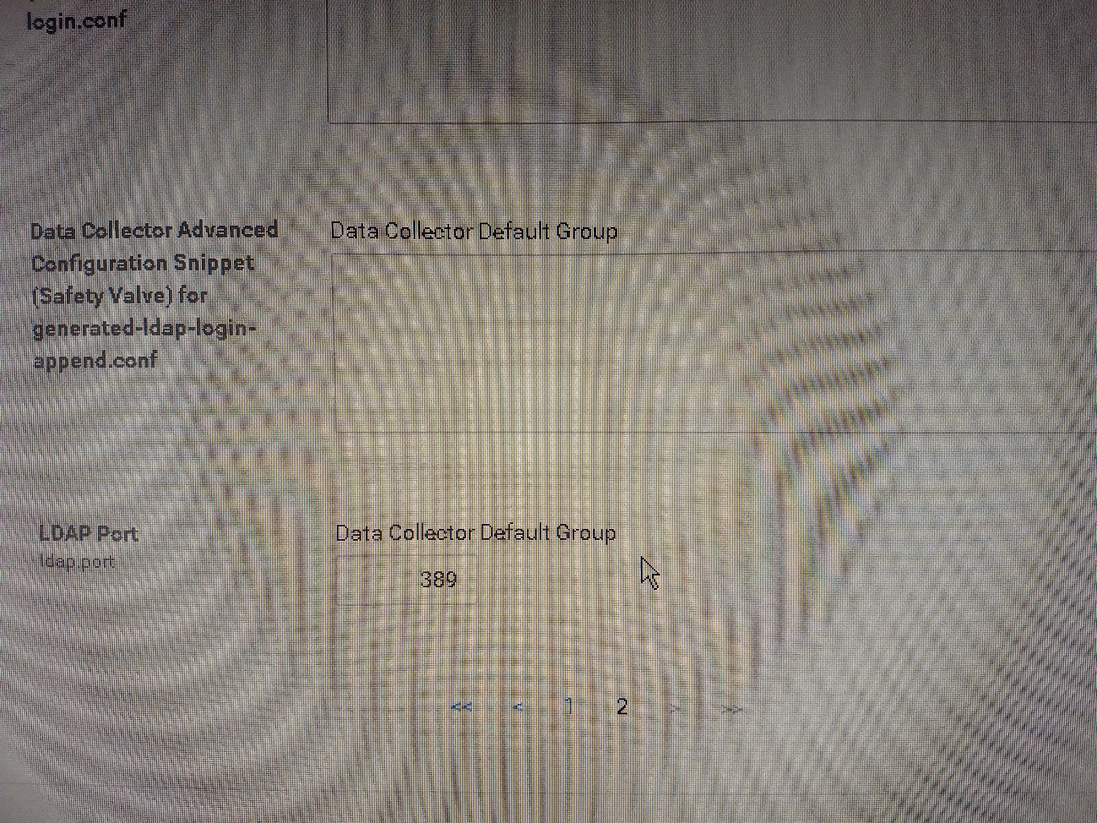

LDAP Port: 389 (default), caso seja LDAPs alterar para 636 e marcar a opção Use LDAPs.

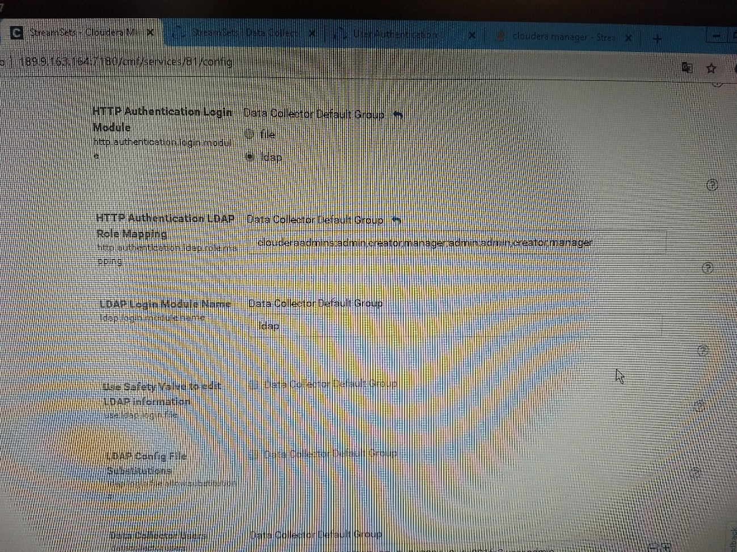

Caso o StreamSets estaja configurado corretamente, o seguinte trecho de log será mostrado:

